**MODULE 5 ASSESSMENT**

**Name:** Josiah Joed G. Getes

**Course & Year:** BSCS – 1

* Write a C++ code to implement a structure for a simple vehicle registration named vehicleReg with member items,
* On function main write an array of structures for vehicleReg, with 5 elements and initialize its content on the code according your preference.
* Pass this array of structures to a function name void reverseContent (vehicleReg x []) to reverse the content of this array of structures.

**CODE:**

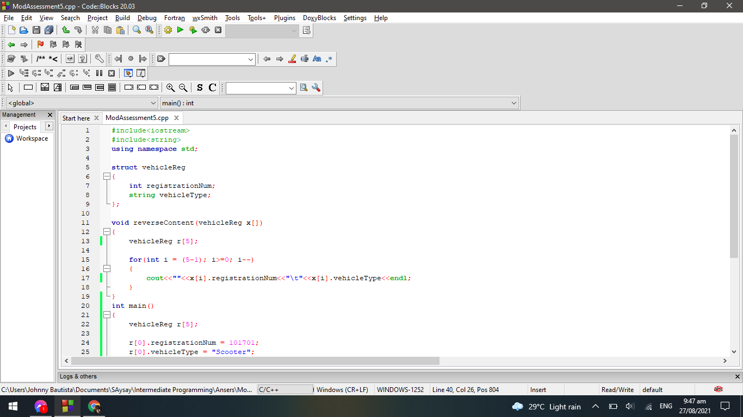

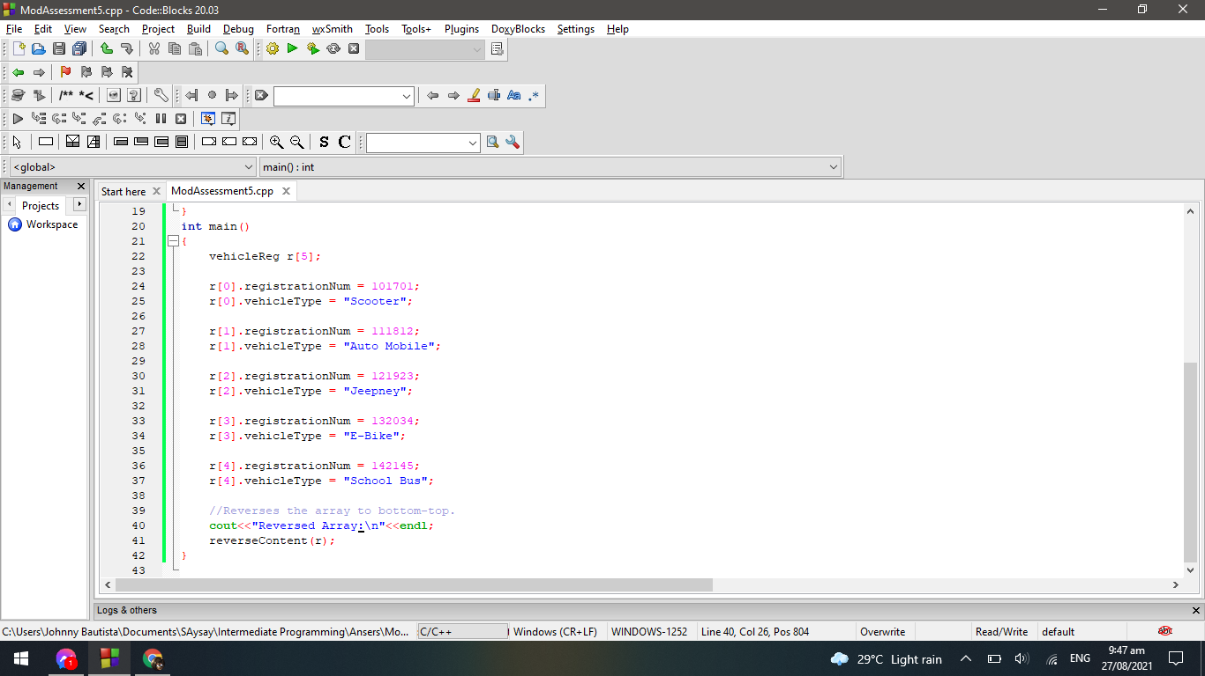

**OUTPUT:**

